**The Passover Story**

Jewish people observe several important days and events in history, such as:Passover: This holiday, which typically occurs in March or April, lasts seven or eight days and celebrates Jewish freedom from slavery in Egypt. Specifically, Passover refers to the biblical story of when the Hebrew God “passed over” houses of Jewish families and saved their children during a plague that was said to have killed all other first-born babies in Egypt.-Rosh Hashanah: Jews celebrate the birth of the universe and humanity during this holiday, which is also known as the Jewish New Year. It generally falls during the months of September or early October.-Passover, or Pesach in Hebrew, is one of the Jewish religion’s most sacred and widely observed holidays. In Judaism, Passover commemorates the story of the Israelites’ departure from ancient Egypt, which appears in the Hebrew Bible’s books of Exodus, Numbers and Deuteronomy, among other texts. Jews observe the weeklong festival with a number of important rituals, including a traditional Passover meal known as a seder, the removal of leavened products from their home, the substitution of matzo for bread and the retelling of the exodus tale

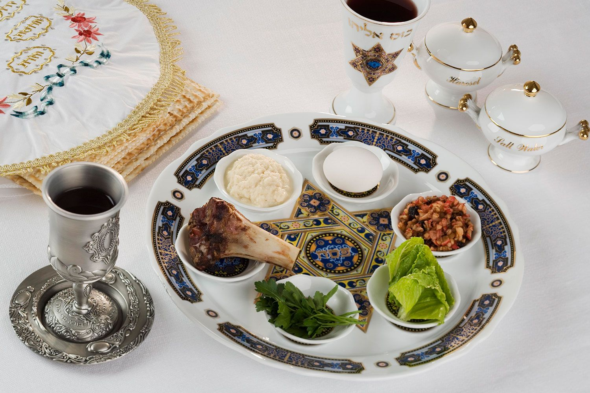

According to the Hebrew Bible, Jewish settlement in ancient Egypt first occurs when Joseph, a son of the patriarch Jacob and founder of one of the 12 tribes of Israel, moves his family there during a severe famine in their homeland of Canaan.For many years the Israelites live in harmony in the province of Goshen, but as their population grows the Egyptians begin to see 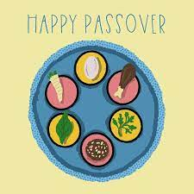them as a threat. After the death of Joseph and his brothers, the story goes, a particularly hostile pharaoh orders their enslavement and the systematic drowning of their firstborn sons in the Nile.-Passover Seder Meaning-On the first two nights of Passover, families and friends gather for a religious feast known as a seder for the Jewish holiday.-During the meal, the story of the exodus from Egypt is read aloud from a special text called the Haggadah (Hebrew for “telling”), and rituals corresponding to various aspects of the narrative are performed. For example, vegetables are dipped into salt water representing the tears Jews shed during their time as slaves, and bitter herbs (usually horseradish) symbolizing the unpleasant years of their bondage are eaten.-A seder plate at the center of the table contains Passover foods with particular significance to the exodus story, including matzo, bitter herbs, a lamb shankbone and a mixture of fruit, nuts and wine known as charoset, which represents the mortar Jews used while bonding bricks as slaves in Egypt.-Other typical menu items include matzo kugel (a pudding made from matzo and apples), poached fish patties called gefilte fish and chicken soup with matzo balls.